
A DAY OF REFRESHING, RENEWING AND HEALING IN THE HOLY SPIRIT
led by the Catholic Evangelist and International Speaker Ros Powell.
‘A day to be renewed in your Faith, in your Hope and in your God-given Mission.’
PRINKNASH MEETING ROOM
Cranham, Glos, GL4 8EX
Saturday 25th April 2026
10.30 - 16.00
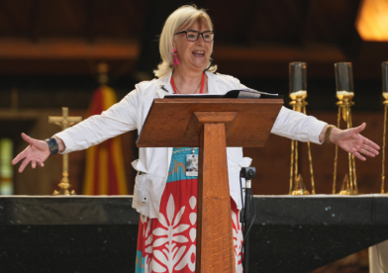
Programme
10.30 - 10.45: Prayer, Praise & Worship
10.45 - 12.30: A Talk on the Holy Spirit, followed by prayer to receive the baptism in the Holy Spirit.
12.30: Lunch
13.30 - 16.00: A talk on the Gifts of the Holy Spirit followed by healing prayers.
The programme and timings are subject to change in response to the work of the Holy Spirit.
Booking is essential due to limited space and anticipated high demand.
e: moira.govan@gmail.com m: 07732 910554
Bring a packed lunch, or pre-order on arrival at Prinknash Café.
Donations on day appreciated to cover costs.

