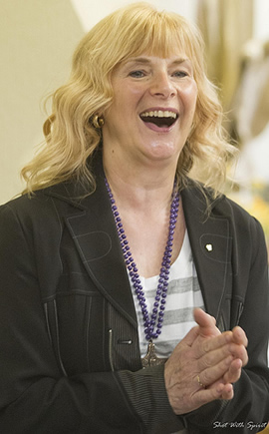**St Joseph’s Prayer Centre**

“Being Transformed As You Go Deeper In Intimacy with the Lord**”**

Retreat with Ros Powell

Oct 20th to Oct 22nd

Residential £175pp includes meals

Non-residential £120pp Includes meals or Non-Residential £85pp without meals

The most important journey in life is the journey inwards, it’s a journey to the depths of our being. On this weekend of transformation, you will learn how to go deeper in your relationship with the Lord through listening to His voice. St Augustine tells us that silence reveals God and 1 Kings 19:11-13 The Lord was in the gentle whisper and not the wind, the earthquake, or fire. Many times, when God speaks to us, He speaks in the quiet recesses of our hearts but we're so busy looking for the "larger-than-life" stuff that we can miss Him. His desire is to reveal the hidden treasures buried within, through intimacy. He seeks to remove the hindrances and the obstacles that prevent us coming boldly into the throne room and moving as one with the Lord. Ross Powell will lay a foundation on ‘going deeper in your walk with Jesus’ which will include some of the teachings of St Teresa of Avila. The weekend will begin with prayer to remove the spiritual obstacles and hindrances that prevent us from listening to Gods voice. “Soaking prayer and contemplation will pave the way, helping you on your spiritual journey to go deeper in your relationship with the Lord”

Holy Mass will be available each day including a Mass of Healing on Saturday at 7pm all welcome.

Please book early as places will fill up quickly

Registration from 3pm on 20th Oct

Conference begins after supper on Friday at 18.00 pm and will finish after lunch on Sunday.

Tel 01704875850 Email:theprayercentre.stj@psmgs.org.uk

St Joseph Prayer Centre, Blundell Avenue, Formby, Liverpool L37 1PH

There will be a collection during the weekend for Ros Powell’s ministry